Student Services Building, Room 241
College of Marin-Kentfield Campus
835 College Ave, Kentfield, CA 94904
Regular Meeting AGENDA
February 22, 2019

- Order of Business
  - Call to Order:
  - Roll Call
OFFICERS | PRESENT | ABSENT
PRESIDENT
LIAM CAMPBELL
VICE PRESIDENT
HELLEN SIGARAN
STUDENT TRUSTEE
JADON SEITZ (voted in on 6/14/18)
SECRETARY
GABBY HOJILLA (voted in 8/31/18)
TREASURER
KAI KONISHI GRAY
SENATOR – TECHNOLOGY
ASHLEY CHANTHONGTHIP (voted in 11/2/18)
SENATOR - STUDENT ACTIVITIES & SERVICES
ANDREA THACH - Proxy = Laurel
SENATOR - STUDENT ACTIVITIES & SERVICES
LAUREL HALVORSON
SENATOR – PUBLIC RELATIONS & MARKETING
FERNANDO SANCHEZ (voted in 6/14/18)
SENATOR – PUBLIC RELATIONS & MARKETING
FITRY RAHMADIANTY(voted in 6/14/18)
STATE STUDENT SENATE REP.
LUCA CITROEN (voted in 2/1/18)
ESCOM REPRESENTATIVE
DENIZE SPRINGER (NON-VOTING MEMBER)

ASCOM ADVISOR: SADIKA SULAIMAN HARA AND TEA PERALES
AUXILIARY MEMBERS: Cayri Chan, Liam Zhu, Thomas Boatright, Amina Nakhuda, Juan Miguel
Hojilla, Blanca Lopez, Paula Denise Sullivan
MEMBERS OF THE GENERAL PUBLIC:

  - Adoption of the Agenda

  - Approval of the Minutes

  - Public Comment

    - This segment of the meeting is reserved for persons desiring to address the ASCOM Executive Board on any matter of concern that is not stated on the agenda. A time limit of three (3) minutes per speaker and ten (10) minutes per topic shall be observed. The law does not permit any action to be taken nor extended discussion of any items not on the agenda. The ASCOM Board or Members may respond briefly to questions or statements, however, for more information please contact the ASCOM President or Secretary to have an item placed on the next regular meeting agenda. (Brown Act 54954.3). This section is reserved for persons who did not request an agenda item in advance.

- New Business (Actions May Be Taken)
  - Discussion/Action on approving funding of $120.00 for the Environmental Action Club (EAC) screening of the Symbiotic Earth documentary. EAC would like to request Fusselman Hall 120 for the location. Possible dates for event would be March 29th, April 5, or April 12.
  - Discussion on Ray James’ proposal of making the balcony on the 3rd floor of the SMN building available to students.
  - Discussion/Action on budget breakdown and to approve NTE $650.00 for the Womxn’s History Celebration on March 13th.
  - Discussion/Action to approve funding for tabling supplies NTE $100.00. Below are options for certain display items:
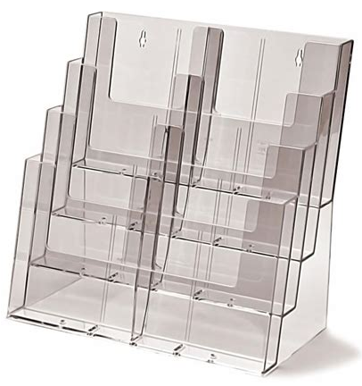

- Standing Business (Actions May Be Taken)

  - Officer Reports:
    - PRESIDENT REPORT:
    - VICE PRESIDENT REPORT:
    - STUDENT TRUSTEE REPORT:
    - SECRETARY REPORT:
    - TREASURER REPORT:
    - SENATOR – TECHNOLOGY:
    - SENATORS (2) – STUDENT ACTIVITIES & SERVICES:
    - SENATORS (2) - PUBLIC RELATIONS & MARKETING:
    - STATE STUDENT SENATE REPRESENTATIVE REPORT:
    - ESCOM REPRESENTATIVE REPORT:
    - ASCOM ADVISORS REPORT:

    - Committee Reports:
    - COLLEGE COUNCIL REPORT:
    - GOVERNANCE REVIEW COUNCIL:
    - PLANNING AND RESOURCE ALLOCATION COMMITTEE:
    - EDUCATIONAL PLANNING COMMITTEE:
    - FACILITIES PLANNING COMMITTEE:
    - INSTRUCTIONAL EQUIPMENT COMMITTEE:
    - PROFESSIONAL LEARNING COMMITTEE:
    - GUIDANCE, RESOURCES, INTEGRATION, TRANSFORMATION COMMITTEE:
    - TECHNOLOGY PLANNING COMMITTEE:
    - INCLUSION, DIVERSITY, EQUALITY, AND ACTION COMMITTEE:

- Communications from the Floor
  - This time is reserved for any member of the Board to make announcements on items that are not on the agenda. A time of limit of three (3) minutes per speaker and ten (10) minutes per topic shall be observed and total time will not be extended.

- Public Comment
  - This segment of the meeting is reserved for persons desiring to address the ASCOM Executive Board on any matter of concern that is not stated on the agenda. A time limit of three (3) minutes per speaker and ten (10) minutes per topic shall be observed. The law does not permit any action to be taken nor extended discussion of any items not on the agenda. The ASCOM Board or Members may respond briefly to questions or statements, however, for more information please contact the ASCOM President or Secretary to have an item placed on the next regular meeting agenda. (Brown Act 54954.3)

- Adjournment:

